**Calculate for graded index fiber**

A graded-index or gradient-index fiber is **an optical fiber whose core has a refractive index that decreases with increasing radial distance from the optical axis of the fiber**.

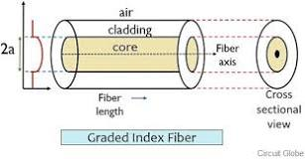

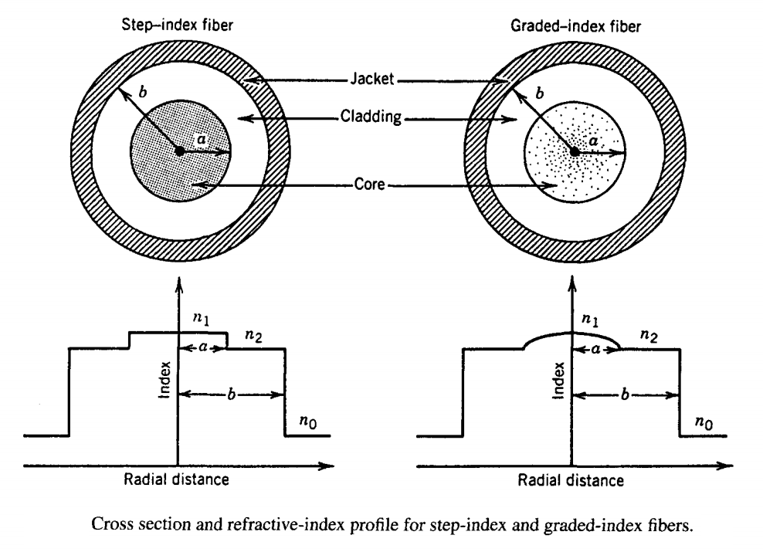

**Program:**

clc;

clear all;

d = input('diameter of core in micrometer=');%.3 to 25 micrometer

n1 = input('enter the index of core =');%1.4 to 1.5

n2 = input('enter the index of cladding =');%1.4 to 1.5 ,n2<n1

lamda = input('enter the operating wavelength of fiber in micrometer =');%1.1 to 1.7 micrometer

NA = ((n1^2)-(n2^2))^(1/2);

disp('numerical aperture of fiber is = ');

disp(NA);

theta = asind(NA);

d = d*1000;% convert diameter micrometer to nanometer

a = d/2;%radius of core

k = 2*pi/lamda;

beta = k*n1*cos(theta);%calculation of propogation constant

disp('propagation constant of fiber is = ');

disp(beta);

b = (((beta^2)/(k^2))-(n2^2))/((n1^2)-(n2^2)); %normalized propogation constant

disp('Normalized propagation constant of fiber is = ');

disp(b);

Vnumber = pi*d*NA/lamda;%calculation of V number

disp('V number = ');

disp(Vnumber);

%find wether fiber is single mode or multi mode

if Vnumber <=2.405

disp('fiber is single mode fiber at given wavelength');

else

disp('fiber is multimode fiber at given wavelength');

end

%graphical representation of V verses normalized propogation constant(b)

x = [1:1:12];% X-axis b- 1 to 12

y = 1-(((a^2)*(((n1^2)*(k^2))-(beta^2)))/(1^2))% Y axis normalized frequency (Vnumber)=Pi*d*NA/wavelength(here i have taken only 1st element of wavlength range)

for i = x(1,2):x(1,12)% in the for loop i have calculated Vnumber for 200 to 4000 nanometer of wavelength

y = [y,1-(((a^2)*(((n1^2)*(k^2))-(beta^2)))/(i^2))];

end

figure(1);

plot(x,y);

grid;

xlabel('Vnumber(unitless)--->');

ylabel('normalized propogatio constant(b)unitless--->');

%graphical representation of V with wavelength

x1=[800:1:2000];% X-axis wavelength from 100 to 4000 range in nanometer

y1=[(pi*d*NA)/800];% Y axis normalized frequency (Vnumber)=Pi*d*NA/wavelength(here i have taken only 1st element of wavlength range)

for j=x1(1,2):x1(1,1201)% in the for loop i have calculated Vnumber for 200 to 4000 nanometer of wavelength

k=2*pi/j;

y1=[y1,(k*d*NA/2)];

end

Vc = 2.405;% normalized frequency(predefined)

CutoffWavelength = pi*d*NA/Vc;

CutoffWavelength = round(CutoffWavelength);

disp('cutoff wavlength(nm) = ');

disp(CutoffWavelength);

figure(2);

plot(x1,y1);

hold on

h = stem(CutoffWavelength,Vc,'LineWidth',1);% indicating the cutoff wavlength on graph by a stem

set(h,'MarkerFaceColor','red');

hold off

annotation('textbox', 'Position',[0.6271 0.7976 0.2021 0.0524], 'FitHeightToText','off','BackgroundColor',[1 0.6431 1], 'String',{sprintf('Cutoff wavelength= %s',...

int2str(CutoffWavelength))});%displaying the value of cutoff wavelength on graph in a text box

title('variation of normalized frequency with wavelength in step index fibers');% title of graph

xlabel('wavelength(nm)--->');

ylabel('V(unitless)--->');

grid;

Lamda = input('operating Wavelength at which number of modes to be calculated in nanometer=');%800 to 1600 nanometer

Vnumber = pi*d*NA/Lamda;

disp('V number=');

disp(Vnumber);

annotation('textbox', 'Position',[0.6271 0.6976 0.1021 0.0424], 'FitHeightToText','off','BackgroundColor',[1 0.6431 1], 'String',{sprintf('Vnumber= %s',...

int2str(Vnumber))})

Ms = (Vnumber^2)/2;%approximate formula for calculating the number of modes

disp('number of modes at operating wavelength=');

Ms = round(Ms);

disp(Ms);

**output:**

